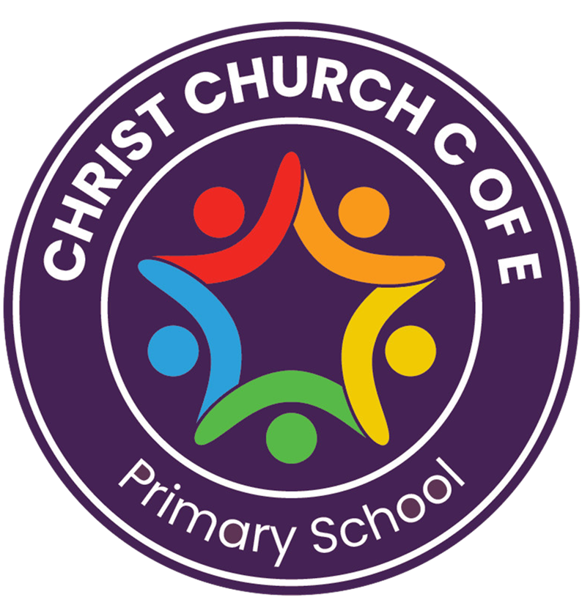
EYFS Policy
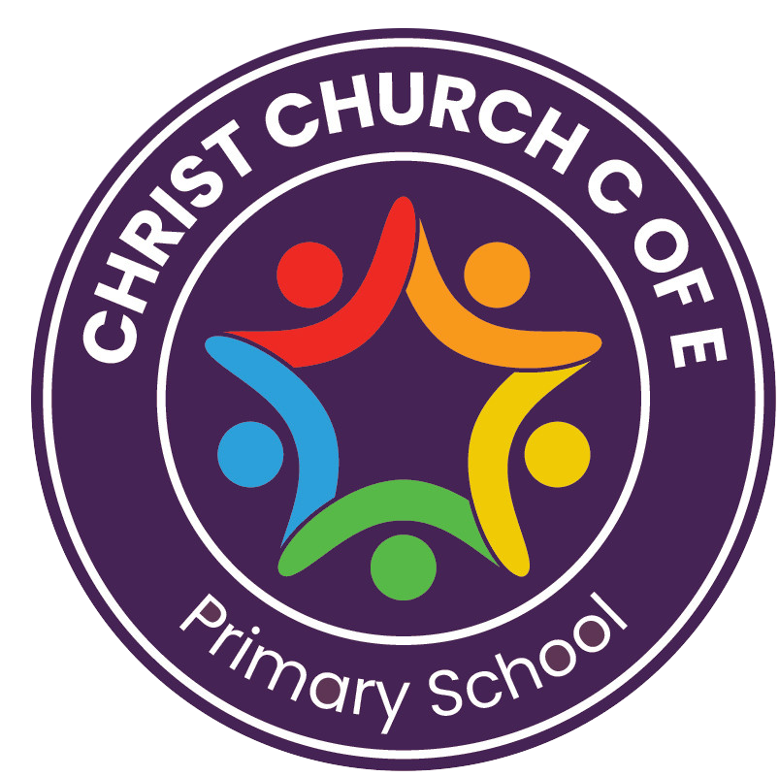

SUCCESS | HAPPY | INCLUDED | NURTURED | ENRICHED
Person responsible for policy: | Elizabeth Povey
Approved by: | FGB | On: | September 2025
Next Review: | September 2026
Version Number: | 1

Vision and Ethos

“In the same way, let your light shine before others, that they may see your good deeds and glorify your Father in heaven.” – Matthew 5:16

At Christ Church CE Primary School, we believe every child is a precious gift from God – unique, deeply loved, and full of potential. Our vision is that every child’s light will shine brightly. Through our SHINE values – Successful, Happy, Included, Nurtured and Enriched – we create a safe, joyful, and faith-filled community where children grow spiritually, academically, socially, and emotionally. Inspired by Jesus’ example of love, hope and generosity, we prepare our children to live life in all its fullness (John 10:10), to serve others, and to make a positive difference in God’s world.

Introduction
This policy sets out the high-quality provision we offer for all children aged three to five years in our Early Years Foundation Stage (EYFS). At Christ Church, we joyfully embrace the 2025 EYFS statutory framework, offering a rich, language-filled and play-based environment that sparks curiosity, celebrates creativity, and nurtures a lifelong love of learning. We see every moment as an opportunity to grow children’s faith, character, and understanding of the world around them.
Our curriculum is guided by the Department for Education’s Strong Foundations report (October 2024), which highlights the importance of securing the essential knowledge and skills that underpin future learning success. This research emphasises that well-planned, purposeful play and high-quality adult interactions enable children to develop strong language, literacy, mathematical and social foundations.
Alongside this, we draw on the Ofsted report “Bold Beginnings” (2017), which reinforces the value of early language and literacy, and on Development Matters (2021), to ensure that our planning and assessment are developmentally appropriate and responsive to every child’s needs.

Rationale

Our EYFS curriculum aims to:

- Nurture happy, confident and resilient learners, ready to shine their light.
- Place communication and language at the heart of all learning, as we know “faith comes by hearing” (Romans 10:17).
- Support children’s physical, social, emotional and spiritual growth, laying strong foundations for lifelong wellbeing.
- Celebrate diversity and inclusion, recognising that we are all fearfully and wonderfully made (Psalm 139:14).
- Build strong partnerships with families, honouring parents as children’s first and most important educators.
- Prepare children for a smooth and joyful transition into Key Stage 1, helping them to flourish academically and spiritually.

Safeguarding and Welfare Requirements

Safeguarding and child welfare are central to all we do. All EYFS staff are trained in safeguarding, paediatric first aid, and the Prevent Duty. The Designated Safeguarding Lead (DSL) oversees all safeguarding practice and ensures compliance with statutory EYFS welfare requirements.
We uphold the highest standards of health, safety, and supervision, including:

- Appropriate staff-to-child ratios
- Secure and hygienic environments
- Risk assessments for all areas and activities
- Safe recruitment practices and annual safeguarding updates
- Clear procedures for reporting and recording concerns
We promote children’s health and wellbeing through healthy snacks, outdoor physical activity, and positive relationships that ensure every child feels safe and valued.

Curriculum Overview: The Seven Areas of Learning

Our curriculum is designed around the seven areas of learning from the EYFS framework, enriched by our Christian distinctiveness:

Prime Areas

Personal, Social and Emotional Development (PSED):
We help children to build strong, loving relationships, manage emotions, and grow in respect and forgiveness, reflecting Christian values of kindness, compassion, and community.
We use positive behaviour strategies rooted in our Christian ethos. Children are supported to recognise feelings, resolve conflict, and develop self-regulation through consistent routines, modelling, and restorative approaches.

Communication and Language (C&L):
Talk is central to our practice. Through stories, songs, questioning, and prayer, children develop confidence to speak and listen, knowing their voice matters.

Physical Development (PD):
Through outdoor play, PE, and hands-on exploration, children strengthen their bodies and learn healthy habits, celebrating that their bodies are God’s good creation.

Specific Areas

Literacy (L):
We immerse children in inspiring stories – including Bible stories – poems, rhymes, and early writing opportunities.

- Nursery: Children follow the Little Wandle Foundations for Phonics scheme. They focus on the foundations for phonics, including listening skills, sound discrimination, rhythm, rhyme, and oral blending and segmenting.
- Reception: Children follow the Little Wandle Letters and Sounds scheme, progressing through Phase 2 and Phase 3, then moving on to Phase 4, building strong early reading and writing skills. Daily phonics sessions are interactive and multi-sensory, and children read decodable books closely matched to their phonics knowledge.

Mathematics (M):
Practical, playful experiences help children explore number, shape, and pattern, marvelling at the order and beauty of God’s world.

Understanding the World (UtW):
Children explore creation, their local community, and the wider world, learning to care for God’s earth and celebrate cultural and religious diversity.

Expressive Arts and Design (EAD):
Children are encouraged to create and express themselves through music, dance, drama, art, and construction – reflecting God’s creativity as the ultimate Creator.

Characteristics of Effective Learning

At Christ Church CE Primary School, we recognise that children learn in different ways and at different rates. The EYFS framework identifies three Characteristics of Effective Learning, which underpin all curriculum areas and help children become motivated, resilient, and confident learners:

- Playing and Exploring – Children investigate and experience things, and “have a go.” We provide rich, stimulating environments, both indoors and outdoors, where children can explore, experiment, and follow their own interests.
- Active Learning – Children concentrate and keep on trying if they encounter difficulties, showing resilience and determination. We support children to develop persistence, curiosity, and confidence in their abilities, encouraging them to reflect on their achievements.
- Creating and Thinking Critically – Children have and develop their own ideas, make links between ideas, and develop strategies for doing things. We provide opportunities for problem-solving, imagination, and decision-making, allowing children to express creativity and think independently.
These characteristics are embedded in our daily practice through play, adult-led activities, and independent learning. Staff observe and support children to ensure they are engaged, motivated, and developing the skills to become lifelong learners.

Provision at Christ Church CofE Primary

We balance child-initiated play, adult-guided activities, and collaborative learning to inspire awe and wonder. Children engage in a mix of whole-class experiences, small-group work, and playful exploration, with learning carefully shaped around their interests to keep them motivated and curious. Practitioners model language, scaffold thinking, and gently extend play, encouraging children to ask questions, share ideas, and reflect on their learning.

Oracy and talk are central to everything we do. From welcome routines and collective worship to small-group activities and outdoor exploration, children are encouraged to express themselves clearly, listen attentively, and engage in meaningful dialogue with peers and adults. Storytelling, role-play, discussion, and reflection are woven seamlessly into all areas of learning, helping children develop rich vocabulary, confidence, and the ability to communicate effectively across a range of contexts.

Continuous provision is thoughtfully planned and regularly enhanced to spark curiosity, independence, and sustained engagement. Children move confidently between whole-class, small-group, and play-based experiences, exploring topics inspired by their own interests while learning to care for shared spaces and each other and building habits of responsibility, respect, and gratitude.

Alongside high-quality play and exploration, carefully planned adult-led sessions build firm foundations in key skills. Maths and Writing sessions are practical, engaging, and multisensory, ensuring children develop confidence in early writing, number sense, and problem-solving. Vocabulary and key concepts are explicitly planned, giving children rich, ambitious language that supports talk, comprehension, and future learning. These sessions remain playful and joyful, allowing children to embed new knowledge in meaningful contexts throughout the day.
Handwriting development is an integral part of our approach to early writing. In Nursery, children develop gross and fine motor skills through activities that build core strength, coordination and dexterity, such as Dough Disco, Squiggle While You Wiggle, and a range of fine motor and mark-making experiences, including threading, tweezing, and drawing. These activities build muscle control, hand–eye coordination, and pre-writing skills to prepare children physically for writing. In Reception, handwriting is taught explicitly and progressively through the Letter-Join scheme. Children start with pre-writing patterns to develop fluency and control before learning to form letters accurately using print script, laying a strong foundation for joining letters in Key Stage 1.

Assessment & Progress

Assessment in the EYFS is continuous, purposeful, and focused on supporting each child’s next steps. Practitioners use their professional knowledge, high-quality interactions, and in-the-moment feedback to respond to children’s learning as it happens. This ensures children are supported, challenged, and guided effectively throughout their day. Phonics and key skills are monitored to provide targeted support or challenge where needed.
For children in Reception, the Reception Baseline Assessment (RBA) is completed during the first six weeks of the school year to establish each child’s starting points. It assesses early mathematics, literacy, and communication & language skills. The data generated is primarily used as a progress measure when a child completes Key Stage 2. In addition, staff complete the first round of school internal assessments by Autumn term, providing a more detailed assessment of each pupil across the 7 areas of learning.

Early language development is further supported and assessed using a baseline WELLCOMM assessment by the end of the first half-term, alongside LanguageScreen, which identifies pupils for the NELI programme where appropriate.

We make every effort to ensure parents and carers are able to share and contribute to the developing whole assessment picture of a child, helping staff to arrive at accurate and meaningful judgements about progress and next steps.

Progress is reviewed regularly and informs planning, ensuring learning experiences are well-matched to each child’s stage of development. Parent consultations are held throughout the year to share progress, celebrate achievements, and discuss next steps. Open communication with parents and carers ensures they are active partners in their child’s learning.

Our approach ensures that every child is known, valued, and supported to make progress, enabling them to reach their God-given potential and transition confidently to the next stage of their education.

Transition into Key Stage 1 is carefully planned and supported. EYFS and KS1 staff collaborate on joint planning, moderation, and classroom visits. Information on each child’s learning profile, strengths, and next steps is shared to ensure a smooth and joyful progression.

Children leave the EYFS as confident, articulate, and compassionate learners – ready to SHINE in Key Stage 1. They are curious, resilient, and respectful, with a strong foundation in communication, literacy, and mathematics. Most importantly, they leave knowing that they are loved by God, valued by their school community, and equipped to live life in all its fullness.

SMSC and Character Education

Spiritual, moral, social and cultural development is at the heart of all we do. Daily collective worship, prayer, and Bible storytelling invite children to wonder, reflect, and grow spiritually. We celebrate Christian festivals as well as cultural diversity, encouraging children to respect, value, and learn from others.

Through our daily practice, we actively promote British Values, helping children to understand fairness, respect, and community. Children learn to take turns, make choices, and respect others’ views.

Online and Digital Safety

As children encounter technology in their early learning, we introduce them to safe, age-appropriate digital experiences. Staff model responsible technology use and ensure that online safety principles, in line with Keeping Children Safe in Education (2024), are embedded from the earliest years.

Inclusion & SEND

We are committed to seeing the light in every child. Children with SEND or additional needs receive personalised support and early intervention so that they can access all aspects of our curriculum. We comply fully with the Equality Act 2010, ensuring equal access and opportunity for every learner. Adaptations are made to meet individual needs, and accessibility is reviewed regularly. We work closely with specialist agencies, parents, and carers to ensure every child can flourish.

For further details about our approach, provision, and graduated response for children with additional needs, please refer to our SEND Policy, which is available on our school website or upon request from the school office.

Organisation & Environment

Our Nursery offers both part-time and full-time places, subject to eligibility and availability. Reception is organised into two classes, each with a maximum of 30 children, led by qualified teachers and skilled practitioners.
Our indoor and outdoor environments are thoughtfully designed to be calm, welcoming, and inspiring, providing the perfect backdrop for curiosity, exploration, and creativity.

Indoor Spaces
Inside, learning areas are carefully arranged to support children in exploring skills and ideas across all areas of the curriculum. These areas are dynamic and evolve throughout the year to reflect children’s developing interests, newly acquired skills, and opportunities to revisit prior learning in meaningful ways. Our indoor spaces use natural resources and flexible layouts to provide security while encouraging imagination and adventure. Enhancements are introduced regularly to spark wonder and extend learning, creating a vibrant yet soothing space where children can flourish.

Outdoor Spaces
Our outdoor area is always accessible during our learning-through-play sessions, offering opportunities for big thinking, big movement, and big imagination. Children can engage in gardening, construction, role play, and physical challenges. Outdoor spaces are designed to promote independence, collaboration, and a love of learning.

Both indoor and outdoor environments reflect our commitment to EYFS practice and embody our Christian ethos of care, respect, and curiosity about God’s world.

Community Links & Enrichment

Children experience the richness of life through carefully planned trips and in-school experiences that are directly linked to their current learning. Visits might include places of worship, local community sites, or themed workshops brought into school, alongside special visitors who bring learning to life and spark curiosity and imagination.

These purposeful experiences deepen children’s understanding of the world around them, build cultural capital, and help them to see themselves as valued, active participants in God’s creation. They inspire wonder, nurture confidence, and encourage children to explore, ask questions, and engage fully with their learning.

Parent Partnership

We believe education is a shared journey of love and trust. Parents are welcomed into our school family through workshops, stay-and-play sessions, curriculum events, and collective worship. Each half term, children take home SHINE homework – a menu of practical, hands-on activities linked to their current learning, which parents and children are encouraged to explore together. SHINE homework supports children’s independence, curiosity, and creativity, allowing them to apply skills, explore ideas, and deepen understanding in meaningful ways.

In addition, children bring home weekly phonics homework to ensure that their new sounds are communicated with families and can be practised at home. They also take home a decodable reading book, carefully matched to their level, alongside a reading-for-pleasure book to share with a family member. This approach supports early reading skills while fostering a love of books and storytelling, encouraging children to enjoy reading as a shared, joyful experience.

Parents are invited to share WOW moments, join celebrations, and maintain ongoing dialogue with staff, helping to strengthen the connection between home and school and to celebrate each child’s progress and achievements.

Professional Development

All EYFS staff are committed to continuous professional development. They regularly engage in training related to phonics, language development, SEND, safeguarding, and EYFS pedagogy. Professional dialogue, coaching, and moderation ensure consistency and reflective practice across the team.

Roles and Responsibilities

Role of the Headteacher
The Headteacher is responsible for ensuring this EYFS policy is reviewed, approved, and applied consistently. They will:

- Maintain a safe, nurturing, and stimulating EYFS environment.
- Support staff in delivering high-quality early years provision.
- Ensure statutory EYFS requirements are met, including safeguarding, welfare, and assessment.
- Monitor children’s progress and ensure any additional needs are addressed.
- Report to governors on EYFS effectiveness and outcomes.
- Promote partnership with parents and carers.

Role of Staff
EYFS staff are responsible for:

- Planning and delivering a rich, play-based curriculum.
- Observing, assessing, and supporting children’s development.
- Providing a safe, inclusive, and nurturing environment.
- Engaging parents in their child’s learning and celebrating achievements.
- Supporting children with additional needs and liaising with relevant professionals.

Role of Parents/Carers
Parents and carers are expected to:

- Support their child’s learning, development, and wellbeing.
- Engage with home learning, including phonics, reading, and SHINE activities.
- Attend consultations and share information about their child.
- Communicate promptly with staff about any concerns.
- Support the school’s values and help children understand expectations.

